PANOPIO, MARY EMMANUELLE R. 2018110880

2-ECE-C

ECE 2112 | Programming Assignment #6

Experiment 6 - Demo 3

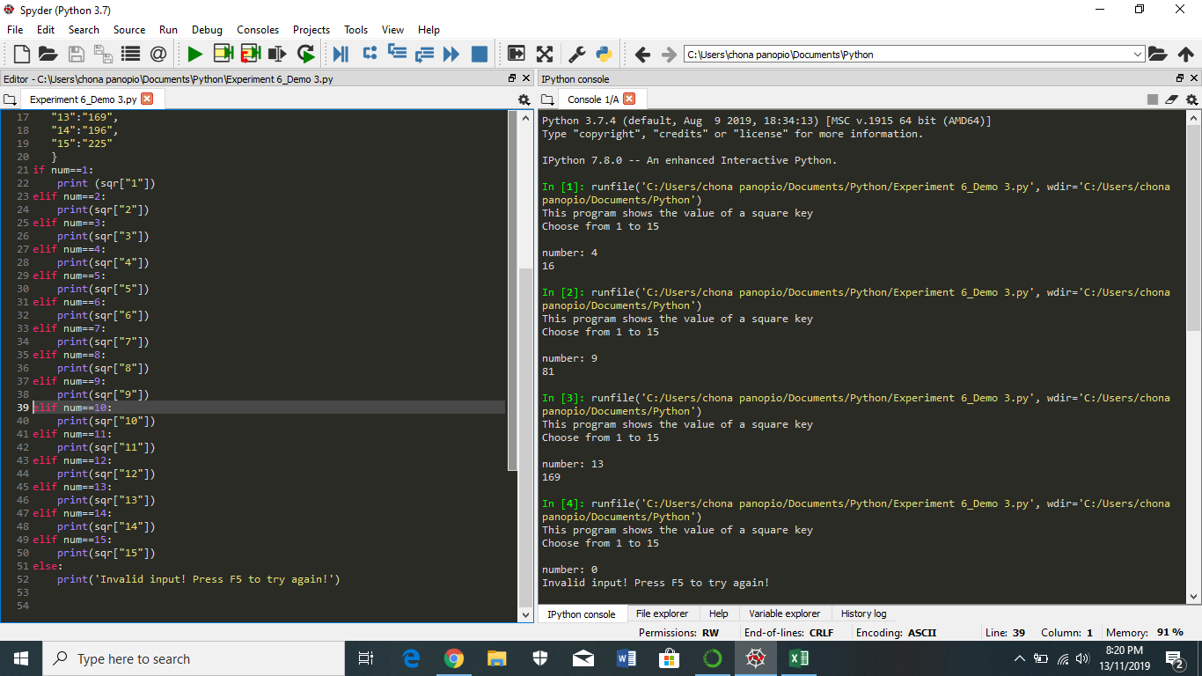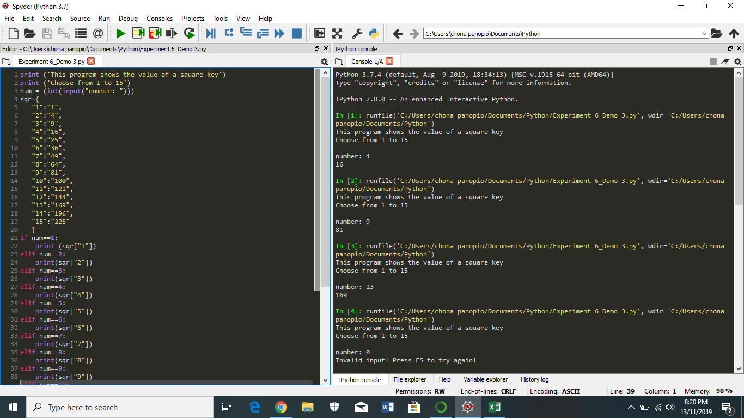

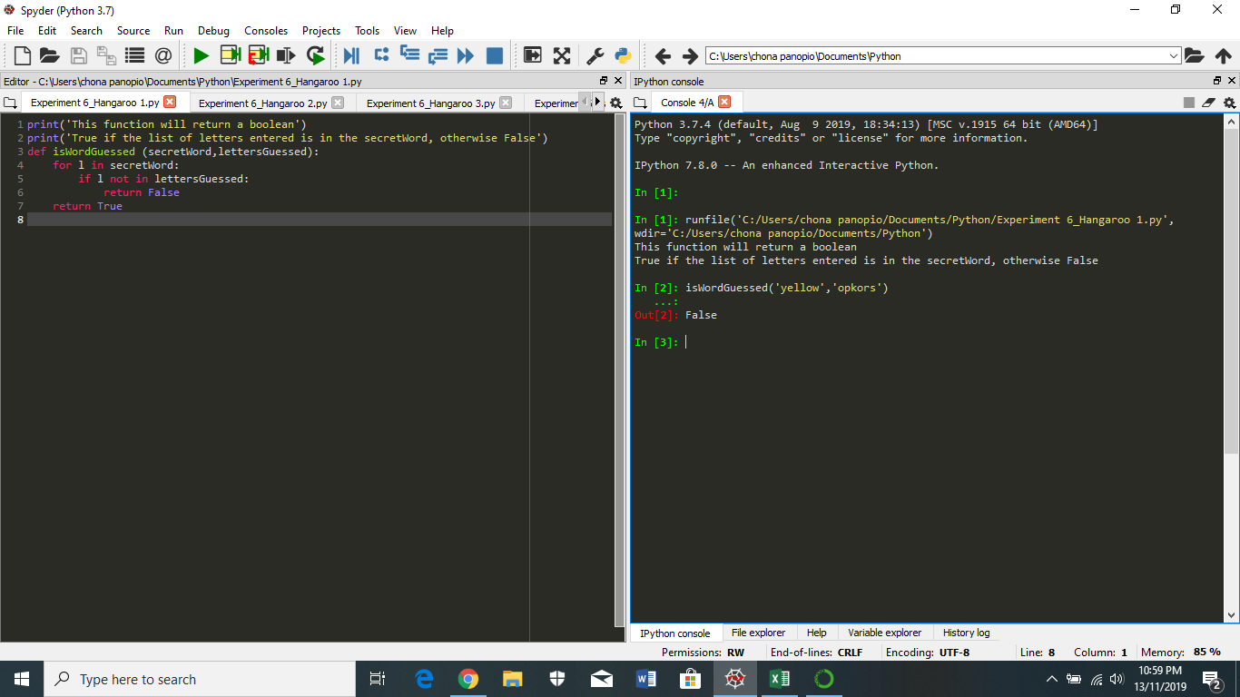Experiment 6 – Hangaroo 1

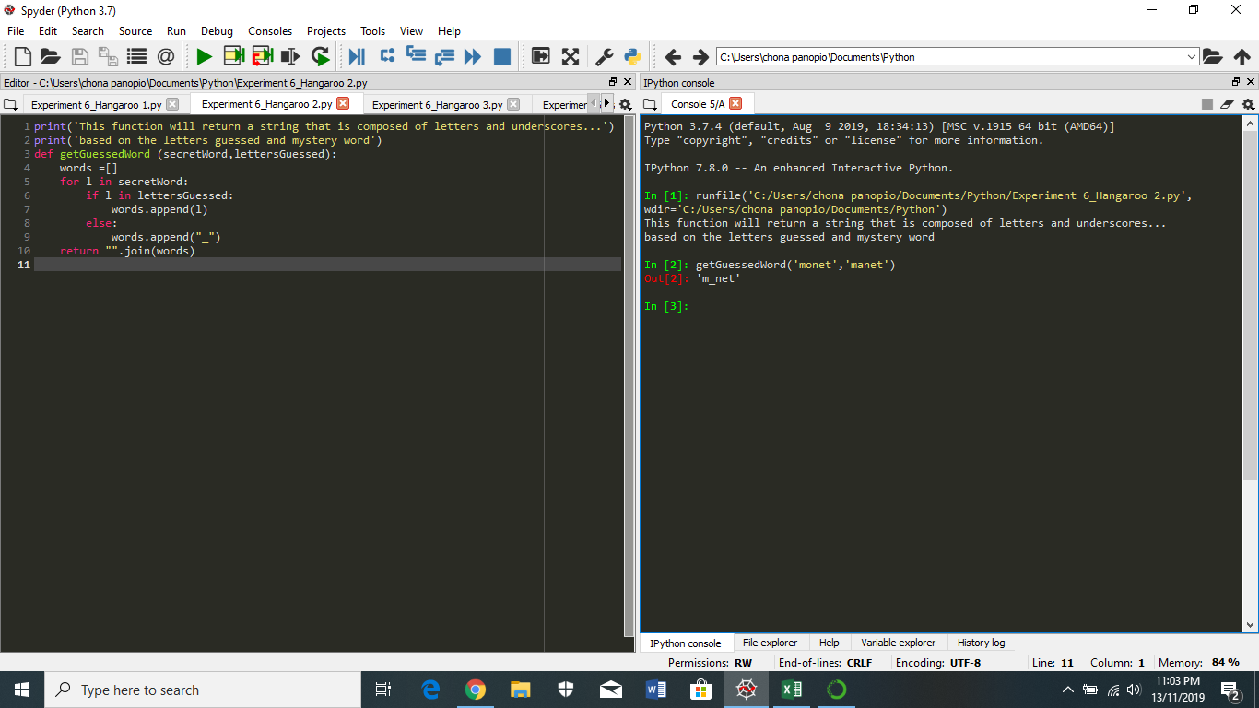Experiment 6 – Hangaroo 2

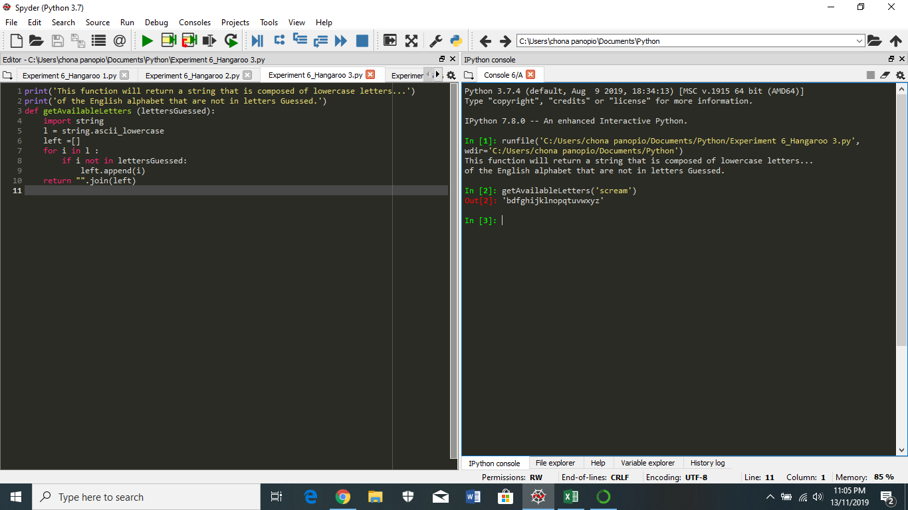Experiment 6 – Hangaroo 3

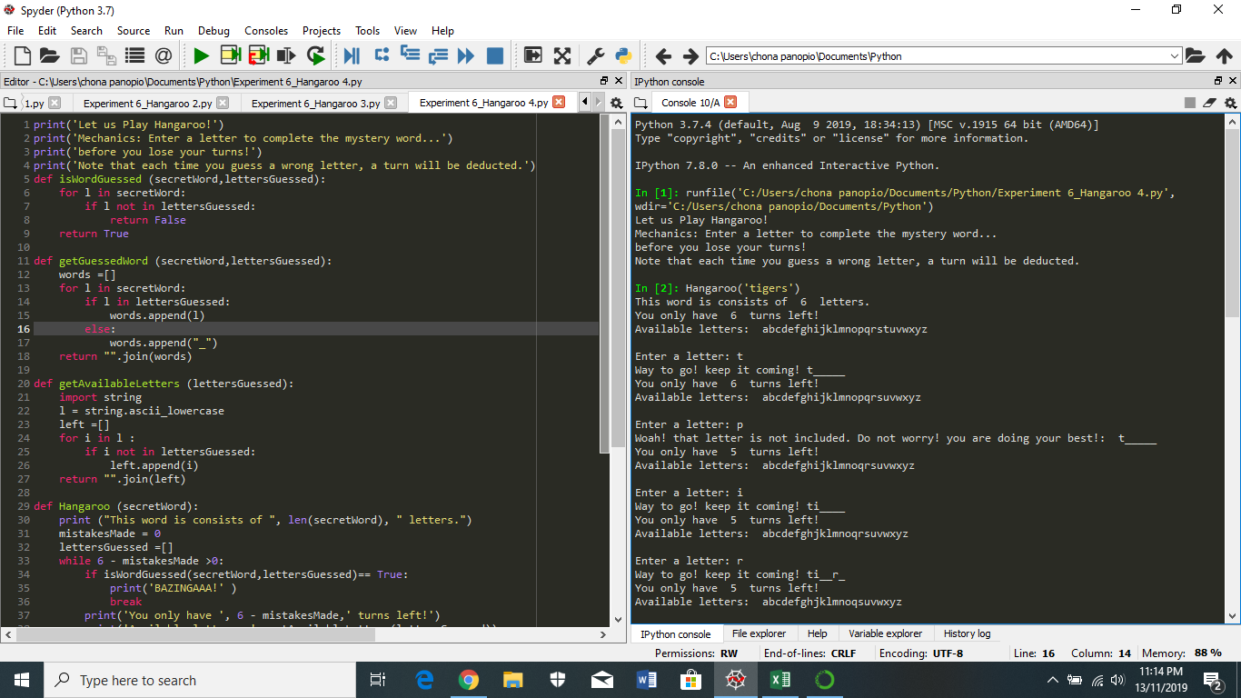Experiment 6 –Hangaroo 4

